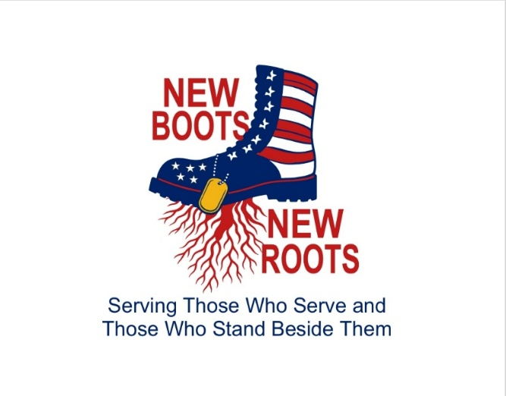
Membership Application
Name:___________________________
ADDRESS: __________________________
__________________________
DOB: ___/___/_____

PHONE:( ) -

EMAIL: ________________________
Enlisted? What Branch?: ______________________________
Family of Enlisted? Relationship?________________________
Interested in Volunteering? ________YES _________NO
If so, in what capacity?________________________________
________________________________________________

Hobbies/Likes(Enlisted):_______________________________
________________________________________________
________________________________________________

Are you currently a member of any Veteran Organization? If so, where?
_____________________________________________________
_____________________________________________________

Additional Family Contact Information(Enlisted):_____________
________________________________________________
________________________________________________
________________________________________________

